Clay Elementary School
School Wide Discipline Program

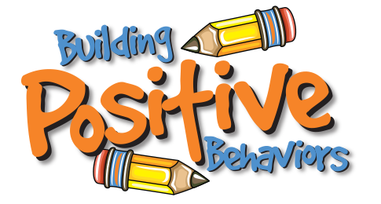
SCHOOL RULES/EXPECTATIONS

I. Follow directions
II. Talk quietly when entering or leaving building
III. No bullying, teasing, name calling, or cursing
IV. Keep hands, feet, food and objects to yourself
V. Do not chew gum in the school building.
VI. Do not bring toys, trading cards, cars, or collectibles
VII. Tobacco products/drugs are prohibited on school property
VIII. No public display of affection, such as hand holding/kissing
IX. Walk, don’t run
X. Use single file and walk on right in hallways at all times.
XI. Do not write or mark on school/other’s property
XII. Put trash in appropriate containers

CONSEQUENCES
First Conduct Report 1 day lunch detention
Second Conduct Report 2 days lunch detention
Third Conduct Report 3 days lunch detention
Fourth Conduct Report 1 day ISS/OSS
Fifth Conduct Report 2 days of ISS/OSS
Sixth Conduct Report 1-3 days OSS

GRADE 5
The following will occur after a student has been assigned 15 days of lunch detention:
First offense 1 day of ISS/OSS
Second offense 2 days of ISS/OSS
Third offense 1-3 days OSS

Any student who receives two conduct reports in one day (chooses to break rules six times) will be assigned ISS, in-school suspension, for willful and repeated disruption of the learning environment. A parent conference will be requested.

ISS and OSS may be assigned whenever school authorities determine that a serious infraction of school rules has occurred. This includes willful refusal to complete school tasks, insubordination, disorderly, vicious, illegal, or immoral conduct, and violations of the Safe School Act.

Serious disruptions to the learning environment at Clay Elementary School may lead to immediate suspension from school for a period of one (1) to ten (10) days. Serious disruptions include:

SERIOUS CONSEQUENCES
I. Fighting
II. Stealing
III. Gambling
IV. Possession of Weapons
V. Possession of Controlled Substances
VI. Purposeful Defiance of Authority
VII. Excessive Aggression/Aggressive Acts
VIII. Willful Destruction of Property
Parents will be required to pay for school property or school materials that are willfully damaged by students.

REWARDS
Students who follow school rules will receive rewards from their classroom teacher and principal. Rewards may include written notes to parents, certificates, free time, privileges, movies, parties, etc.

